The Black Creek and its many beautiful and expansive wetlands team with numerous animal and plant species, including reptiles, amphibians, birds, some 25 species of native fish, and macroinvertebrates. Some of the more interesting wildlife species include the river otter, beaver, swan, warblers, assorted turtles, and the Northern Cricket frog. Common fish of the upper reaches include pickerel, herring, bullhead, sunfish, bluegill, largemouth bass, black crappie, perch, pike, and brown trout, while the lower reaches in direct contact with the Hudson River sometimes sport shad, striped bass, and sturgeon.

WHY ARE WETLANDS IMPORTANT?

● PROVIDE WATER QUALITY AND AIR IMPROVEMENT – RECOGNIZED BY FEDERAL & STATE GOVERNMENTS

● HELP CLEANSE WATER OF POLLUTANTS AND PROVIDE IMPORTANT NATURAL CHEMICALS

● MODERATE FLOODS – PROVIDE STORAGE CAPACITY

● CONTRIBUTE TO DOWNGRADIENT STREAM FLOW

● CAN PROVIDE GROUNDWATER RECHARGE

● PROVIDE VALUABLE WILDLIFE AND FISHERIES HABITAT FOR COMMON, THREATENED AND ENDANGERED SPECIES

● OFTEN COUPLED TO ADJACENT ECOSYSTEMS THROUGH CHEMICAL EXCHANGES

● PROVIDE NUTRIENTS OF CHEMICALS ESSENTIAL FOR LIFE – PHOSPHORUS, NITROGEN, CARBON

● PROVIDE AESTHETIC AND LAND VALUE QUALITIES

● HAVE RECREATIONAL VALUE

● PROVIDE EDUCATIONAL OPPORTUNITIES
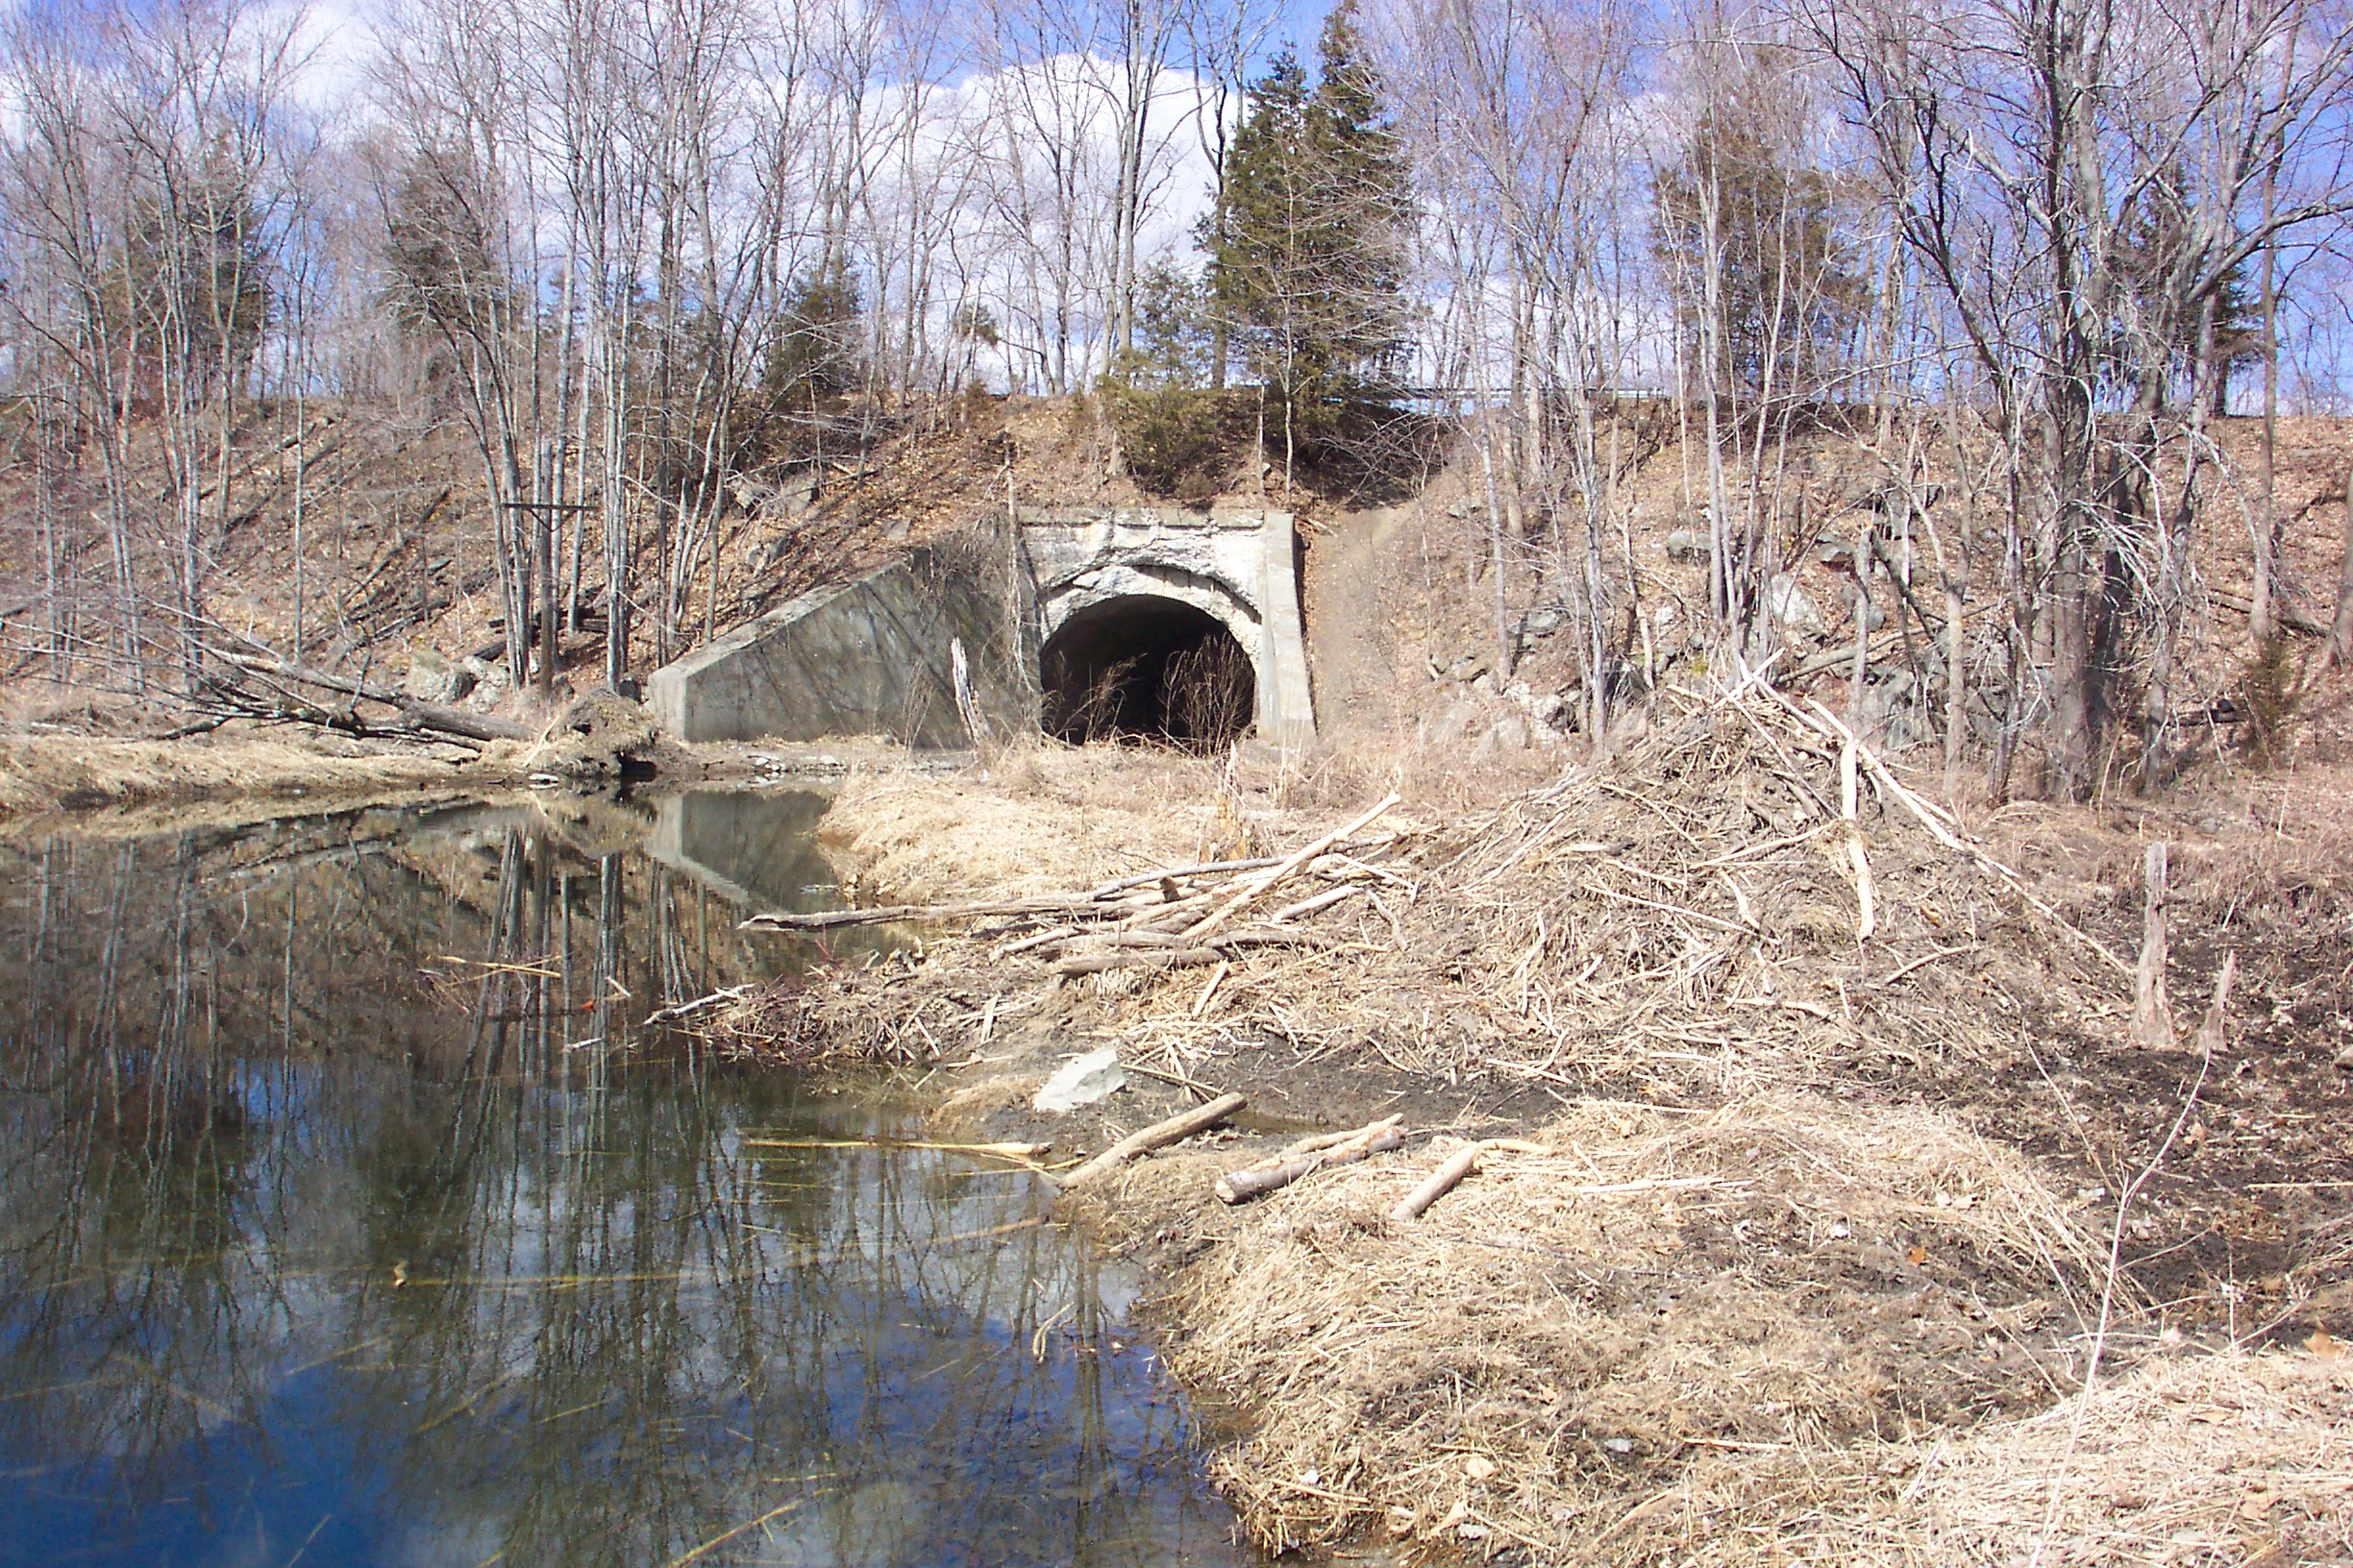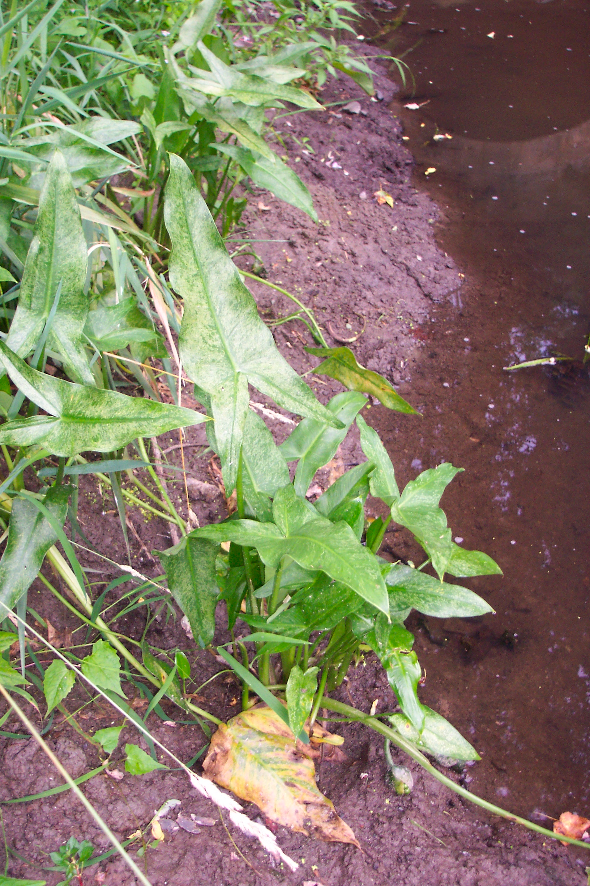
Beaver lodge upstream of Rail Trial Arrowhead near staff plate

